For this analysis, we’re going to try to get means and standard errors for each time point by group for some longitudinal data. We’ll use multiple imputation to do this task.

**\*Example - Schizophrenia**

**Data analyzed by Hedeker and Gibbons (1997). A randomized trial for schizophrenia. The trial contained 312 patients received drug therapy and 101 received placebo. The measurements were taken at weeks 0, 1, 3, 6,**

**but some subjects have missing data due to dropout. The outcome of interest is severity of illness (1 = normal, ... , 7 = extremely ill);**

**data** BIOS755.schizo;

input ID Group week severity;

sqrtweek = week**(**0.5**);

r_severity = round(severity);

datalines;

1103 1 0 5.5

1103 1 1 3.0

1103 1 3 2.5

1103 1 6 4.0

1104 1 0 6.0

1104 1 1 3.0

1104 1 3 1.5

1104 1 6 2.5

………………………………

9316 0 1 6.0

9316 0 3 6.5

9316 0 6 6.0

**run**;

**\* To run the imputation, we first want to change the data from long to wide:**

**\* Going from long to wide (this will only output the outcome and id):**

**proc** **transpose** data=BIOS755.schizo out=schizo_wide prefix=Y;

by id;

id week;

var severity;

**run**;

**\* Merging the wide outcome data with the other covariate data:**

**data** BIOS755.schizo_wide;

merge BIOS755.schizo schizo_wide;

by id;

if first.id;

drop week severity sqrtweek r_severity _NAME_ _LABEL_;

**run**;

**proc** **print** data = BIOS755.schizo_wide (obs=**10**);

**run**;

| **Obs** | **ID** | **Group** | **Y0** | **Y1** | **Y3** | **Y6** |
| --- | --- | --- | --- | --- | --- | --- |
| **1** | 1103 | 1 | 5.5 | 3.0 | 2.5 | 4.0 |
| **2** | 1104 | 1 | 6.0 | 3.0 | 1.5 | 2.5 |
| **3** | 1105 | 1 | 4.0 | 3.0 | 1.0 | . |
| **4** | 1106 | 1 | 3.0 | 1.0 | 1.5 | 1.0 |
| **5** | 1107 | 0 | 5.0 | 5.0 | 5.0 | 5.5 |
| **6** | 1108 | 1 | 6.0 | 6.0 | 3.5 | 4.5 |
| **7** | 1109 | 1 | 4.0 | 2.0 | 2.0 | 2.5 |
| **8** | 1110 | 1 | 4.0 | 4.5 | 4.0 | 3.5 |
| **9** | 1111 | 1 | 5.5 | 5.5 | 5.5 | 2.5 |
| **10** | 1113 | 1 | 4.0 | 2.5 | 4.5 | 3.0 |

**proc** **sort** data = BIOS755.schizo_wide;

by group;

**run**;

**\* Running the imputation on the wide data;**

**\* First have an imputation model for Y1 (Y0 has no missingness);**

**\* Then we have an imputation model for Y3 given Y0, group, and the imputed Y1;**

**\* Then we have an imputation model for Y6 given Y0, group, and the imputed Y1 & Y3;**

**proc** **mi** data=BIOS755.schizo_wide NIMPUTE=**10** seed=**8675309** out=MI_wide;

class group;

fcs nbiter=**20** plots=trace regpmm (Y1 = Y0 group Y0*group/ k = **8**);

fcs nbiter=**20** plots=trace regpmm (Y3 = Y1 Y0 group Y0*group Y1*group/ k = **8**);

fcs nbiter=**20** plots=trace regpmm (Y6 = Y3 Y1 Y0 group Y0*group Y1*group Y3*group/ k = **8**);

var Y0 group Y1 Y3 Y6;

**run**;

Imputation Methods

[DISCRIM](https://documentation.sas.com/doc/en/pgmsascdc/9.4_3.3/statug/statug_mi_syntax05.htm#statug.mi.fcsdiscrimopt)

Specifies the discriminant function method

[LOGISTIC](https://documentation.sas.com/doc/en/pgmsascdc/9.4_3.3/statug/statug_mi_syntax05.htm#statug.mi.fcslogisticopt)

Specifies the logistic regression method

[REG](https://documentation.sas.com/doc/en/pgmsascdc/9.4_3.3/statug/statug_mi_syntax05.htm#statug.mi.fcsregopt)

Specifies the regression method

[REGPMM](https://documentation.sas.com/doc/en/pgmsascdc/9.4_3.3/statug/statug_mi_syntax05.htm#statug.mi.fcsregpmmopt)

Specifies the predictive mean matching method

**ORDER=FREQ | VAR**

specifies the variable ordering in which to impute missing values in the filled-in and imputation phases. The ORDER=FREQ option orders the variables by the descending frequency counts of variables and the ORDER=VAR orders the variables as specified in the VAR statement. The default is ORDER=FREQ.

|  |
| --- |
| The SAS System |

The MI Procedure

| **Model Information** | |
| --- | --- |
| **Data Set** | BIOS755.SCHIZO_WIDE |
| **Method** | FCS |
| **Number of Imputations** | 10 |
| **Number of Burn-in Iterations** | 20 |
| **Seed for random number generator** | 8675309 |

| **FCS Model Specification** | |
| --- | --- |
| **Method** | **Imputed Variables** |
| Regression | Y0 |
| Regression-PMM( K= 8) | Y1 Y3 Y6 |
| Discriminant Function | Group |

| **Missing Data Patterns** | | | | | | | | | | | |
| --- | --- | --- | --- | --- | --- | --- | --- | --- | --- | --- | --- |
| **Group** | **Y0** | **Group** | **Y1** | **Y3** | **Y6** | **Freq** | **Percent** | **Group Means** | | | |
| **Y0** | **Y1** | **Y3** | **Y6** |
| **1** | X | X | X | X | X | 312 | 75.54 | 5.379808 | 4.562821 | 4.092949 | 3.349038 |
| **2** | X | X | X | X | . | 53 | 12.83 | 5.320755 | 4.500000 | 3.641509 | . |
| **3** | X | X | X | . | . | 45 | 10.90 | 5.566667 | 4.744444 | . | . |
| **4** | X | X | . | . | . | 3 | 0.73 | 4.500000 | . | . | . |

The MI Procedure

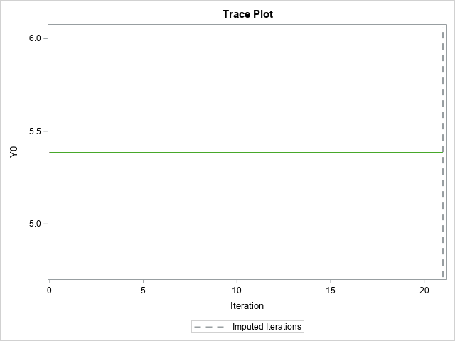

The MI Procedure

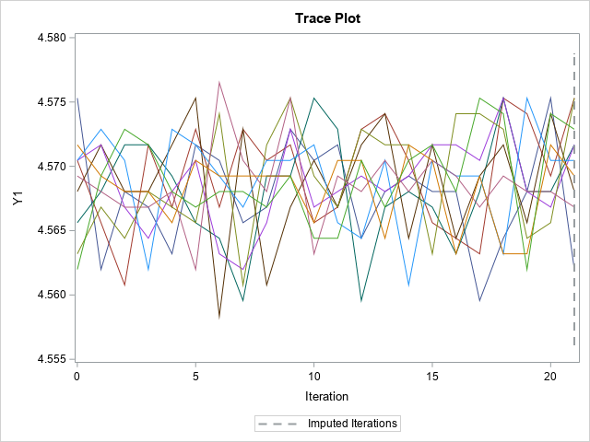

The MI Procedure

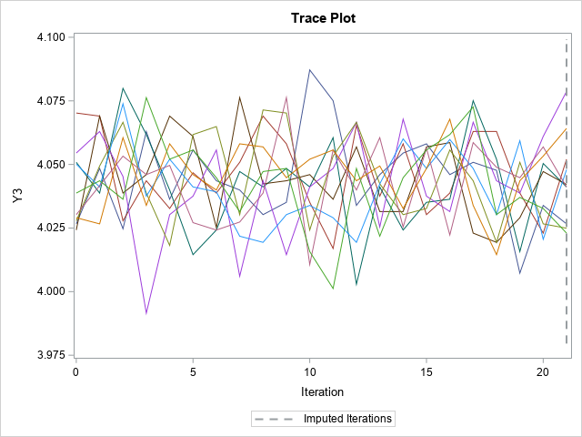

The MI Procedure

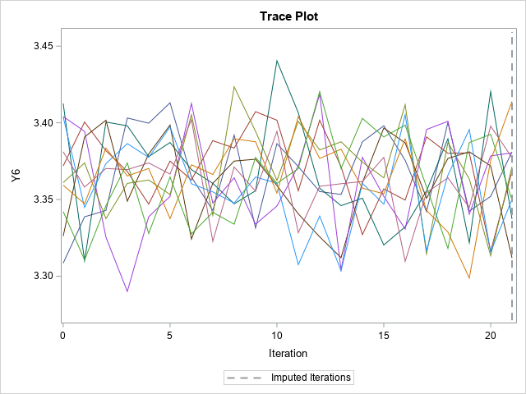

| **Variance Information (10 Imputations)** | | | | | | | |
| --- | --- | --- | --- | --- | --- | --- | --- |
| **Variable** | **Variance** | | | **DF** | **Relative Increase in Variance** | **Fraction Missing Information** | **Relative Efficiency** |
| **Between** | **Within** | **Total** |
| **Y1** | 0.000016432 | 0.003695 | 0.003714 | 407.58 | 0.004891 | 0.004873 | 0.999513 |
| **Y3** | 0.000313 | 0.005299 | 0.005643 | 332.17 | 0.064940 | 0.061755 | 0.993862 |
| **Y6** | 0.000794 | 0.005859 | 0.006733 | 214 | 0.149081 | 0.132977 | 0.986877 |

| **Parameter Estimates (10 Imputations)** | | | | | | | | | | |
| --- | --- | --- | --- | --- | --- | --- | --- | --- | --- | --- |
| **Variable** | **Mean** | **Std Error** | **95% Confidence Limits** | | **DF** | **Minimum** | **Maximum** | **Mu0** | **t for H0: Mean=Mu0** | **Pr > |t|** |
| **Y1** | 4.570339 | 0.060939 | 4.450545 | 4.690133 | 407.58 | 4.561985 | 4.575303 | 0 | 75.00 | <.0001 |
| **Y3** | 4.044189 | 0.075123 | 3.896412 | 4.191965 | 332.17 | 4.023002 | 4.078692 | 0 | 53.83 | <.0001 |
| **Y6** | 3.364165 | 0.082054 | 3.202427 | 3.525903 | 214 | 3.311864 | 3.414044 | 0 | 41.00 | <.0001 |

**proc** **print** data = MI_wide (obs=**10**);

**run**;

| **Obs** | **_Imputation_** | **ID** | **Group** | **Y0** | **Y1** | **Y3** | **Y6** |
| --- | --- | --- | --- | --- | --- | --- | --- |
| **1** | 1 | 1107 | 0 | 5.0 | 5.0 | 5.0 | 5.5 |
| **2** | 1 | 1115 | 0 | 5.5 | 4.5 | 5.5 | 4.5 |
| **3** | 1 | 1124 | 0 | 5.0 | 5.0 | 4.0 | 4.5 |
| **4** | 1 | 1129 | 0 | 6.0 | 4.5 | 3.5 | 2.0 |
| **5** | 1 | 1136 | 0 | 5.0 | 5.5 | 4.5 | 5.5 |
| **6** | 1 | 1140 | 0 | 5.5 | 6.0 | 6.0 | 6.5 |
| **7** | 1 | 1301 | 0 | 5.0 | 2.5 | 2.5 | 3.5 |
| **8** | 1 | 1306 | 0 | 4.5 | 5.0 | 1.5 | 2.5 |
| **9** | 1 | 1309 | 0 | 6.0 | 6.0 | 3.5 | 2.0 |
| **10** | 1 | 1313 | 0 | 6.5 | 6.0 | 6.0 | 6.0 |

**\* Now we’ll do a simple analysis (means and standard errors) for each timepoint based on the imputed data;**

**\* First, we’ll analyze the data by _imputation_;**

**proc** **means** data=MI_wide mean stderr;

by _imputation_ group;

var Y0 Y1 Y3 Y6;

output out=MI_mn mean=mn_Y0 mn_Y1 mn_Y3 mn_Y6 stderr=SE_Y0 SE_Y1 SE_Y3 SE_Y6;

**run** ;

**proc** **sort** data=MI_mn ;

by group _imputation_ ;

**run** ;

**\* Second, we’ll use mianalyze to summarize;**

**proc** **mianalyze** data=MI_mn ;

by group ;

modeleffects mn_Y0 mn_Y1 mn_Y3 mn_Y6 ;

stderr SE_Y0 SE_Y1 SE_Y3 SE_Y6;

ods output parameterestimates=outcombine_1 ;

**run** ;

|  |
| --- |
| The SAS System |

The MIANALYZE Procedure

Group=0

| **Model Information** | |
| --- | --- |
| **Data Set** | WORK.MI_MN |
| **Number of Imputations** | 10 |

| **Variance Information (10 Imputations)** | | | | | | | |
| --- | --- | --- | --- | --- | --- | --- | --- |
| **Parameter** | **Variance** | | | **DF** | **Relative Increase in Variance** | **Fraction Missing Information** | **Relative Efficiency** |
| **Between** | **Within** | **Total** |
| **mn_Y0** | 0 | 0.006536 | 0.006536 | . | 0 | . | . |
| **mn_Y1** | 0 | 0.013068 | 0.013068 | . | 0 | . | . |
| **mn_Y3** | 0.000465 | 0.013100 | 0.013611 | 6379.7 | 0.039025 | 0.037861 | 0.996228 |
| **mn_Y6** | 0.008918 | 0.019539 | 0.029349 | 80.563 | 0.502033 | 0.350170 | 0.966168 |

| **Parameter Estimates (10 Imputations)** | | | | | | | | | | |
| --- | --- | --- | --- | --- | --- | --- | --- | --- | --- | --- |
| **Parameter** | **Estimate** | **Std Error** | **95% Confidence Limits** | | **DF** | **Minimum** | **Maximum** | **Theta0** | **t for H0: Parameter=Theta0** | **Pr > |t|** |
| **mn_Y0** | 5.373267 | 0.080848 | . | . | . | 5.373267 | 5.373267 | 0 | . | . |
| **mn_Y1** | 4.990099 | 0.114317 | . | . | . | 4.990099 | 4.990099 | 0 | . | . |
| **mn_Y3** | 4.862475 | 0.116667 | 4.633768 | 5.091183 | 6379.7 | 4.829703 | 4.897030 | 0 | 41.68 | <.0001 |
| **mn_Y6** | 4.492574 | 0.171315 | 4.151682 | 4.833466 | 80.563 | 4.358416 | 4.625743 | 0 | 26.22 | <.0001 |

The MIANALYZE Procedure

Group=1

| **Model Information** | |
| --- | --- |
| **Data Set** | WORK.MI_MN |
| **Number of Imputations** | 10 |

| **Variance Information (10 Imputations)** | | | | | | | |
| --- | --- | --- | --- | --- | --- | --- | --- |
| **Parameter** | **Variance** | | | **DF** | **Relative Increase in Variance** | **Fraction Missing Information** | **Relative Efficiency** |
| **Between** | **Within** | **Total** |
| **mn_Y0** | 0 | 0.002423 | 0.002423 | . | 0 | . | . |
| **mn_Y1** | 0.000028793 | 0.004877 | 0.004909 | 216214 | 0.006494 | 0.006461 | 0.999354 |
| **mn_Y3** | 0.000816 | 0.007005 | 0.007903 | 697.41 | 0.128158 | 0.116130 | 0.988520 |
| **mn_Y6** | 0.001135 | 0.006478 | 0.007727 | 344.47 | 0.192805 | 0.166465 | 0.983626 |

| **Parameter Estimates (10 Imputations)** | | | | | | | | | | |
| --- | --- | --- | --- | --- | --- | --- | --- | --- | --- | --- |
| **Parameter** | **Estimate** | **Std Error** | **95% Confidence Limits** | | **DF** | **Minimum** | **Maximum** | **Theta0** | **t for H0: Parameter=Theta0** | **Pr > |t|** |
| **mn_Y0** | 5.390385 | 0.049222 | . | . | . | 5.390385 | 5.390385 | 0 | . | . |
| **mn_Y1** | 4.434455 | 0.070064 | 4.297131 | 4.571779 | 216214 | 4.423397 | 4.441026 | 0 | 63.29 | <.0001 |
| **mn_Y3** | 3.779295 | 0.088898 | 3.604755 | 3.953835 | 697.41 | 3.742628 | 3.832372 | 0 | 42.51 | <.0001 |
| **mn_Y6** | 2.998878 | 0.087904 | 2.825981 | 3.171775 | 344.47 | 2.952564 | 3.054167 | 0 | 34.12 | <.0001 |

**proc** **print** data=outcombine_1;

**run**;

| **Obs** | **Group** | **NImpute** | **Parm** | **Estimate** | **StdErr** | **LCLMean** | **UCLMean** | **DF** | **Min** | **Max** | **Theta0** | **tValue** | **Probt** |
| --- | --- | --- | --- | --- | --- | --- | --- | --- | --- | --- | --- | --- | --- |
| **1** | 0 | 10 | mn_Y0 | 5.373267 | 0.080848 | . | . | . | 5.373267 | 5.373267 | 0 | . | . |
| **2** | 0 | 10 | mn_Y1 | 4.990099 | 0.114317 | . | . | . | 4.990099 | 4.990099 | 0 | . | . |
| **3** | 0 | 10 | mn_Y3 | 4.862475 | 0.116667 | 4.633768 | 5.091183 | 6379.7 | 4.829703 | 4.897030 | 0 | 41.68 | <.0001 |
| **4** | 0 | 10 | mn_Y6 | 4.492574 | 0.171315 | 4.151682 | 4.833466 | 80.563 | 4.358416 | 4.625743 | 0 | 26.22 | <.0001 |
| **5** | 1 | 10 | mn_Y0 | 5.390385 | 0.049222 | . | . | . | 5.390385 | 5.390385 | 0 | . | . |
| **6** | 1 | 10 | mn_Y1 | 4.434455 | 0.070064 | 4.297131 | 4.571779 | 216214 | 4.423397 | 4.441026 | 0 | 63.29 | <.0001 |
| **7** | 1 | 10 | mn_Y3 | 3.779295 | 0.088898 | 3.604755 | 3.953835 | 697.41 | 3.742628 | 3.832372 | 0 | 42.51 | <.0001 |
| **8** | 1 | 10 | mn_Y6 | 2.998878 | 0.087904 | 2.825981 | 3.171775 | 344.47 | 2.952564 | 3.054167 | 0 | 34.12 | <.0001 |

**proc** **means** data = BIOS755.schizo_wide mean stderr clm alpha=**0.05**;

var Y0 Y1 Y3 Y6;

by group;

**run**;

The MEANS Procedure

Group=0

| **Variable** | **Mean** | **Std Error** | **Lower 95% CL for Mean** | **Upper 95% CL for Mean** |
| --- | --- | --- | --- | --- |
| |  | | --- | | **Y0** | | **Y1** | | **Y3** | | **Y6** | | |  | | --- | | 5.3732673 | | 4.9900990 | | 4.7927711 | | 4.3156250 | | |  | | --- | | 0.0808481 | | 0.1143168 | | 0.1234220 | | 0.1781494 | | |  | | --- | | 5.2128670 | | 4.7632978 | | 4.5472455 | | 3.9596219 | | |  | | --- | | 5.5336677 | | 5.2169002 | | 5.0382967 | | 4.6716281 | |

Group=1

| **Variable** | **Mean** | **Std Error** | **Lower 95% CL for Mean** | **Upper 95% CL for Mean** |
| --- | --- | --- | --- | --- |
| |  | | --- | | **Y0** | | **Y1** | | **Y3** | | **Y6** | | |  | | --- | | 5.3903846 | | 4.4388350 | | 3.8021277 | | 3.0995968 | | |  | | --- | | 0.0492222 | | 0.0703168 | | 0.0867251 | | 0.0892931 | | |  | | --- | | 5.2935341 | | 4.3004728 | | 3.6314143 | | 2.9237238 | | |  | | --- | | 5.4872352 | | 4.5771971 | | 3.9728411 | | 3.2754698 | |

data schizo_long;

set MI_wide;

by _imputation_;

week=0;

severity=Y0;

sqrtweek = week**(0.5);

r_severity = round(severity);

output;

week=1;

severity=Y1;

sqrtweek = week**(0.5);

r_severity = round(severity);

output;

week=3;

severity=Y3;

sqrtweek = week**(0.5);

r_severity = round(severity);

output;

week = 6;

severity=Y6;

sqrtweek = week**(0.5);

r_severity = round(severity);

output;

output;

drop Y0 - Y6;

run;

proc glimmix data=schizo_long method=QUAD(qpoints=20);

by _imputation_;

class ID;

model r_severity = Group sqrtweek Group*sqrtweek/solution link=cumlogit dist=multinomial covb;

random intercept/subject=ID type=UN G;

ods output ParameterEstimates=mixparms CovB=mixcovb;

run;

quit;

**The GLIMMIX Procedure**

**Imputation Number=1**

| **Model Information** | |
| --- | --- |
| **Data Set** | WORK.SCHIZO_LONG |
| **Response Variable** | r_severity |
| **Response Distribution** | Multinomial (ordered) |
| **Link Function** | Cumulative Logit |
| **Variance Function** | Default |
| **Variance Matrix Blocked By** | ID |
| **Estimation Technique** | Maximum Likelihood |
| **Likelihood Approximation** | Gauss-Hermite Quadrature |
| **Degrees of Freedom Method** | Containment |

| **Class Level Information** | | |
| --- | --- | --- |
| **Class** | **Levels** | **Values** |
| **ID** | 413 | 1103 1104 …. 9316 |

|  |  |
| --- | --- |
| **Number of Observations Read** | 2065 |
| **Number of Observations Used** | 2065 |

| **Response Profile** | | |
| --- | --- | --- |
| **Ordered Value** | **r_severity** | **Total Frequency** |
| **The GLIMMIX procedure is modeling the probabilities of levels of r_severity having lower Ordered Values in the Response Profile table.** | | |
| **1** | 1 | 113 |
| **2** | 2 | 214 |
| **3** | 3 | 265 |
| **4** | 4 | 374 |
| **5** | 5 | 473 |
| **6** | 6 | 523 |
| **7** | 7 | 103 |

| **Dimensions** | |
| --- | --- |
| **G-side Cov. Parameters** | 1 |
| **Columns in X** | 9 |
| **Columns in Z per Subject** | 1 |
| **Subjects (Blocks in V)** | 413 |
| **Max Obs per Subject** | 5 |

| **Optimization Information** | |
| --- | --- |
| **Optimization Technique** | Dual Quasi-Newton |
| **Parameters in Optimization** | 10 |
| **Lower Boundaries** | 1 |
| **Upper Boundaries** | 0 |
| **Fixed Effects** | Not Profiled |
| **Starting From** | GLM estimates |
| **Quadrature Points** | 20 |

| **Iteration History** | | | | | |
| --- | --- | --- | --- | --- | --- |
| **Iteration** | **Restarts** | **Evaluations** | **Objective Function** | **Change** | **Max Gradient** |
| **0** | **0** | 4 | 6246.2209238 | . | 181.2061 |
| **1** | **0** | 2 | 6119.7986792 | 126.42224456 | 148.073 |
| **2** | **0** | 2 | 6084.2757253 | 35.52295396 | 358.4737 |
| **3** | **0** | 2 | 6039.7454613 | 44.53026400 | 209.4177 |
| **4** | **0** | 3 | 6021.6823831 | 18.06307819 | 122.7434 |
| **5** | **0** | 2 | 5989.8411125 | 31.84127061 | 89.32346 |
| **6** | **0** | 2 | 5944.9999945 | 44.84111795 | 81.78881 |
| **7** | **0** | 3 | 5925.9813321 | 19.01866246 | 63.43059 |
| **8** | **0** | 3 | 5916.7433289 | 9.23800313 | 23.42529 |
| **9** | **0** | 3 | 5911.3717035 | 5.37162538 | 15.65413 |
| **10** | **0** | 3 | 5910.1900331 | 1.18167041 | 20.30721 |
| **11** | **0** | 4 | 5906.7392412 | 3.45079196 | 18.64359 |
| **12** | **0** | 3 | 5905.1062513 | 1.63298991 | 6.520598 |
| **13** | **0** | 3 | 5904.707514 | 0.39873724 | 5.402078 |
| **14** | **0** | 3 | 5904.6197756 | 0.08773845 | 1.510322 |
| **15** | **0** | 3 | 5904.6130912 | 0.00668441 | 0.25839 |
| **16** | **0** | 3 | 5904.6129354 | 0.00015580 | 0.036091 |
| **17** | **0** | 3 | 5904.6129341 | 0.00000130 | 0.00516 |

|  |
| --- |
| Convergence criterion (GCONV=1E-8) satisfied. |

| **Fit Statistics** | |
| --- | --- |
| **-2 Log Likelihood** | 5904.61 |
| **AIC (smaller is better)** | 5924.61 |
| **AICC (smaller is better)** | 5924.72 |
| **BIC (smaller is better)** | 5964.85 |
| **CAIC (smaller is better)** | 5974.85 |
| **HQIC (smaller is better)** | 5940.53 |

| **Fit Statistics for Conditional Distribution** | |
| --- | --- |
| **-2 log L(r_severity | r. effects)** | 4734.78 |

| **Estimated G Matrix** | | |
| --- | --- | --- |
| **Effect** | **Row** | **Col1** |
| Intercept | **1** | 4.3985 |

| **Covariance Parameter Estimates** | | | |
| --- | --- | --- | --- |
| **Cov Parm** | **Subject** | **Estimate** | **Standard Error** |
| **UN(1,1)** | ID | 4.3985 | 0.4306 |

| **Solutions for Fixed Effects** | | | | | | |
| --- | --- | --- | --- | --- | --- | --- |
| **Effect** | **r_severity** | **Estimate** | **Standard Error** | **DF** | **t Value** | **Pr > |t|** |
| **Intercept** | 1 | -7.8791 | 0.3365 | 411 | -23.41 | <.0001 |
| **Intercept** | 2 | -5.9237 | 0.3098 | 411 | -19.12 | <.0001 |
| **Intercept** | 3 | -4.4812 | 0.2967 | 411 | -15.11 | <.0001 |
| **Intercept** | 4 | -2.8171 | 0.2843 | 411 | -9.91 | <.0001 |
| **Intercept** | 5 | -0.7281 | 0.2756 | 411 | -2.64 | 0.0086 |
| **Intercept** | 6 | 2.9675 | 0.2935 | 411 | 10.11 | <.0001 |
| **Group** |  | 0.04435 | 0.3118 | 1645 | 0.14 | 0.8869 |
| **sqrtweek** |  | 0.6120 | 0.09639 | 1645 | 6.35 | <.0001 |
| **Group*sqrtweek** |  | 1.3676 | 0.1135 | 1645 | 12.05 | <.0001 |

| **Type III Tests of Fixed Effects** | | | | |
| --- | --- | --- | --- | --- |
| **Effect** | **Num DF** | **Den DF** | **F Value** | **Pr > F** |
| **Group** | 1 | 1645 | 0.02 | 0.8869 |
| **sqrtweek** | 1 | 1645 | 40.32 | <.0001 |
| **Group*sqrtweek** | 1 | 1645 | 145.24 | <.0001 |

proc print data = mixparms;  
run;

| **Obs** | **_Imputation_** | **Effect** | **r_severity** | **Estimate** | **StdErr** | **DF** | **tValue** | **Probt** |
| --- | --- | --- | --- | --- | --- | --- | --- | --- |
| **1** | 1 | Intercept | 1 | -7.8791 | 0.3365 | 411 | -23.41 | <.0001 |
| **2** | 1 | Intercept | 2 | -5.9237 | 0.3098 | 411 | -19.12 | <.0001 |
| **3** | 1 | Intercept | 3 | -4.4812 | 0.2967 | 411 | -15.11 | <.0001 |
| **4** | 1 | Intercept | 4 | -2.8171 | 0.2843 | 411 | -9.91 | <.0001 |
| **5** | 1 | Intercept | 5 | -0.7281 | 0.2756 | 411 | -2.64 | 0.0086 |
| **6** | 1 | Intercept | 6 | 2.9675 | 0.2935 | 411 | 10.11 | <.0001 |
| **7** | 1 | Group | _ | 0.04435 | 0.3118 | 1645 | 0.14 | 0.8869 |
| **8** | 1 | sqrtweek | _ | 0.6120 | 0.09639 | 1645 | 6.35 | <.0001 |
| **9** | 1 | Group*sqrtweek | _ | 1.3676 | 0.1135 | 1645 | 12.05 | <.0001 |
| **10** | 2 | Intercept | 1 | -7.8142 | 0.3329 | 411 | -23.47 | <.0001 |
| **11** | 2 | Intercept | 2 | -5.7813 | 0.3061 | 411 | -18.89 | <.0001 |
| **12** | 2 | Intercept | 3 | -4.3582 | 0.2934 | 411 | -14.85 | <.0001 |
| **13** | 2 | Intercept | 4 | -2.7541 | 0.2816 | 411 | -9.78 | <.0001 |
| **14** | 2 | Intercept | 5 | -0.7094 | 0.2733 | 411 | -2.60 | 0.0098 |
| **15** | 2 | Intercept | 6 | 2.9659 | 0.2926 | 411 | 10.14 | <.0001 |

proc mianalyze parms=mixparms covb(effectvar=rowcol)=mixcovb ;

*The covb is only needed for multi-variate results (i.e., type III tests or contrast statements;

modeleffects Group sqrtweek Group*sqrtweek;

title 'MIANALYZE Results';

run;

**MIANALYZE Results**

**The MIANALYZE Procedure**

| **Model Information** | |
| --- | --- |
| **PARMS Data Set** | WORK.MIXPARMS |
| **COVB Data Set** | WORK.MIXCOVB |
| **Number of Imputations** | 10 |

| **Variance Information (10 Imputations)** | | | | | | | |
| --- | --- | --- | --- | --- | --- | --- | --- |
| **Parameter** | **Variance** | | | **DF** | **Relative Increase in Variance** | **Fraction Missing Information** | **Relative Efficiency** |
| **Between** | **Within** | **Total** |
| **intercept** | 0.002157 | 0.085704 | 0.088076 | 12401 | 0.027686 | 0.027097 | 0.997298 |
| **Group** | 0.000994 | 0.095855 | 0.096948 | 70810 | 0.011402 | 0.011302 | 0.998871 |
| **sqrtweek** | 0.002798 | 0.009201 | 0.012278 | 143.28 | 0.334456 | 0.260877 | 0.974576 |
| **Group*sqrtweek** | 0.003340 | 0.012673 | 0.016346 | 178.2 | 0.289877 | 0.233289 | 0.977203 |

| **Parameter Estimates (10 Imputations)** | | | | | | | | | | |
| --- | --- | --- | --- | --- | --- | --- | --- | --- | --- | --- |
| **Parameter** | **Estimate** | **Std Error** | **95% Confidence Limits** | | **DF** | **Minimum** | **Maximum** | **Theta0** | **t for H0: Parameter=Theta0** | **Pr > |t|** |
| **intercept** | 2.935096 | 0.296777 | 2.35337 | 3.516825 | 12401 | 2.847742 | 2.999106 | 0 | 9.89 | <.0001 |
| **Group** | 0.060386 | 0.311365 | -0.54989 | 0.670660 | 70810 | 0.001450 | 0.118389 | 0 | 0.19 | 0.8462 |
| **sqrtweek** | 0.692863 | 0.110807 | 0.47383 | 0.911892 | 143.28 | 0.602466 | 0.757790 | 0 | 6.25 | <.0001 |
| **Group*sqrtweek** | 1.304536 | 0.127853 | 1.05224 | 1.556837 | 178.2 | 1.208516 | 1.376741 | 0 | 10.20 | <.0001 |

From non-imputed data:

| **Solutions for Fixed Effects** | | | | | | | |
| --- | --- | --- | --- | --- | --- | --- | --- |
| **Effect** | **r_severity** | **Group** | **Estimate** | **Standard Error** | **DF** | **t Value** | **Pr > |t|** |
| **Intercept** | 1 |  | -5.3218 | 0.2523 | 411 | -21.09 | <.0001 |
| **Intercept** | 2 |  | -3.8528 | 0.2188 | 411 | -17.61 | <.0001 |
| **Intercept** | 3 |  | -2.8738 | 0.2090 | 411 | -13.75 | <.0001 |
| **Intercept** | 4 |  | -1.7987 | 0.2015 | 411 | -8.93 | <.0001 |
| **Intercept** | 5 |  | -0.4393 | 0.1951 | 411 | -2.25 | 0.0249 |
| **Intercept** | 6 |  | 1.9550 | 0.2127 | 411 | 9.19 | <.0001 |
| **Group** |  | 1 | -0.01599 | 0.2220 | 1080 | -0.07 | 0.9426 |
| **Group** |  | 0 | 0 | . | . | . | . |
| **sqrtweek** |  |  | 0.4862 | 0.1138 | 1080 | 4.27 | <.0001 |
| **sqrtweek*Group** |  | 1 | 0.8172 | 0.1299 | 1080 | 6.29 | <.0001 |
| **sqrtweek*Group** |  | 0 | 0 | . | . | . | . |

| **Type III Tests of Fixed Effects** | | | | |
| --- | --- | --- | --- | --- |
| **Effect** | **Num DF** | **Den DF** | **F Value** | **Pr > F** |
| **Group** | 1 | 1080 | 0.01 | 0.9426 |
| **sqrtweek** | 1 | 1080 | 176.53 | <.0001 |
| **sqrtweek*Group** | 1 | 1080 | 39.60 | <.0001 |